**11. ReactJS-HOL**

**Implementation:**

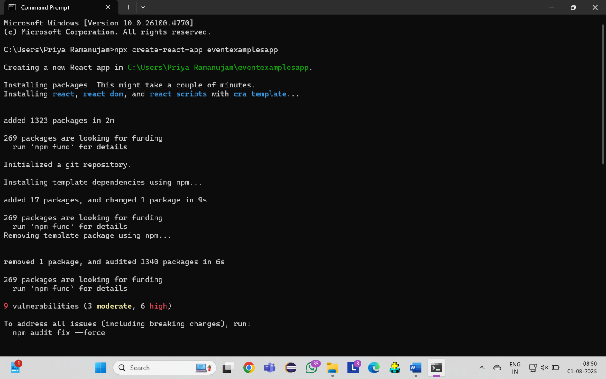

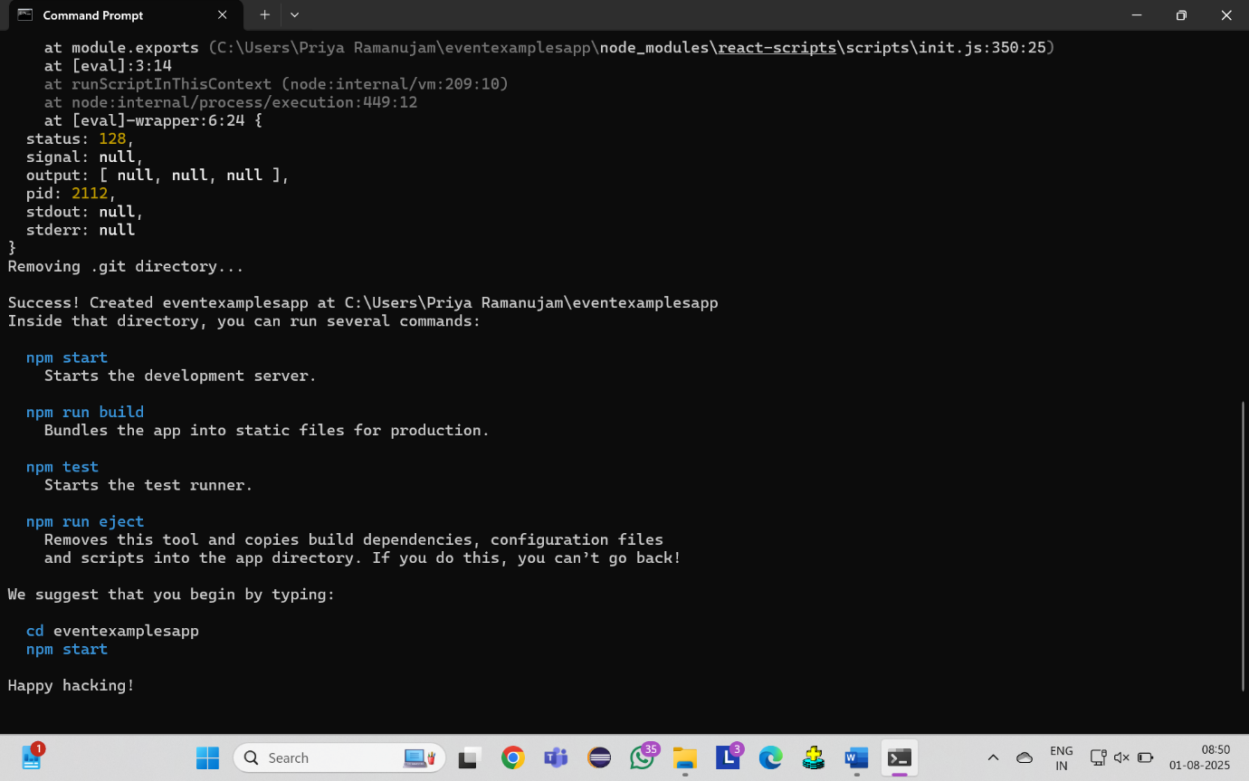

**App.js**

import React, { useState } from 'react';

function App() {

  return (

    <div style={{ padding: '20px' }}>

      <h1>React Event Handling Lab</h1>

        {/* Counter Component */}

      <CounterComponent />

            {/* Welcome Component */}

      <WelcomeComponent />

            {/* Synthetic Event Component */}

      <SyntheticEventComponent />

            {/* Currency Converter */}

      <CurrencyConverter />

    </div>

  );

}

function CounterComponent() {

  const [counter, setCounter] = useState(0);

  const incrementValue = () => {

    setCounter(counter + 1);

  };

  const sayHello = () => {

    alert("Hello! This is a static message from increment button!");

  };

  const handleIncrement = () => {

    incrementValue();

    sayHello();

  };

  const handleDecrement = () => {

    setCounter(counter - 1);

  };

  return (

    <div style={{

      border: '2px solid blue',

      padding: '20px',

      margin: '20px 0',

      backgroundColor: '#f0f0f0'

    }}>

      <h2>Counter Component</h2>

      <div style={{ fontSize: '24px', margin: '20px 0' }}>

        Counter Value: {counter}

      </div>

      <button onClick={handleIncrement} style={{ margin: '5px', padding: '10px' }}>

        Increment

      </button>

      <button onClick={handleDecrement} style={{ margin: '5px', padding: '10px' }}>

        Decrement

      </button>

    </div>

  );

}

function WelcomeComponent() {

  const displayWelcome = (message) => {

    alert(`Welcome! ${message}`);

  };

  return (

    <div style={{

      border: '2px solid green',

      padding: '20px',

      margin: '20px 0',

      backgroundColor: '#f0f0f0'

    }}>

      <h2>Welcome Component</h2>

      <button

        onClick={() => displayWelcome("Thank you for visiting our React app!")}

        style={{ margin: '5px', padding: '10px' }}

      >

        Say Welcome

      </button>

    </div>

  );

}

function SyntheticEventComponent() {

  const handleOnPress = (syntheticEvent) => {

    console.log('Synthetic Event:', syntheticEvent);

    console.log('Event Type:', syntheticEvent.type);

    console.log('Target Element:', syntheticEvent.target);

    alert("I was clicked!");

  };

  return (

    <div style={{

      border: '2px solid orange',

      padding: '20px',

      margin: '20px 0',

      backgroundColor: '#f0f0f0'

    }}>

      <h2>Synthetic Event Component</h2>

      <p>This button demonstrates React's Synthetic Event system</p>

      <button onClick={handleOnPress} style={{ margin: '5px', padding: '10px' }}>

        OnPress Event

      </button>

    </div>

  );

}

function CurrencyConverter() {

  const [rupees, setRupees] = useState('');

  const [euros, setEuros] = useState('');

  const [isConverted, setIsConverted] = useState(false);

  const exchangeRate = 90; // 1 Euro = 90 INR

  const handleInputChange = (e) => {

    setRupees(e.target.value);

    setIsConverted(false);

    setEuros('');

  };

  const handleSubmit = () => {

    if (rupees && !isNaN(rupees)) {

      const convertedAmount = (parseFloat(rupees) / exchangeRate).toFixed(2);

      setEuros(convertedAmount);

      setIsConverted(true);

    } else {

      alert('Please enter a valid amount in Rupees');

    }

  };

  return (

    <div style={{

      border: '2px solid purple',

      padding: '20px',

      margin: '20px 0',

      backgroundColor: '#f0f0f0'

    }}>

      <h2>Currency Converter (INR to Euro)</h2>

      <div style={{ margin: '15px 0' }}>

        <label style={{ display: 'block', marginBottom: '5px' }}>

          Enter amount in Indian Rupees:

        </label>

        <input

          type="number"

          value={rupees}

          onChange={handleInputChange}

          placeholder="Enter INR amount"

          style={{ padding: '8px', margin: '5px' }}

        />

      </div>

        <button onClick={handleSubmit} style={{ margin: '5px', padding: '10px' }}>

        Convert to Euro

      </button>

           {isConverted && (

        <div style={{

          marginTop: '15px',

          padding: '10px',

          backgroundColor: 'lightgreen',

          border: '1px solid green'

        }}>

          ₹{rupees} INR = €{euros} EUR

          <br />

          Exchange Rate: 1 EUR = {exchangeRate} INR

        </div>

      )}

    </div>

  );

}

export default App;

